Cycle - 1

1) Define a class ‘product’ with data members pcode, pname and price. Create 3 objects of the class and find the product having the lowest price.

Code:

public class product

{

int pcode;

int price;

String pname;

void getdata(int p1,String p2,int p3)

{

pcode = p1;

pname = p2;

price = p3;

}

public static void main(String[]args)

{

System.out.println("Name : APARNA MOHAN");

System.out.println("Reg no : SJC 22MCA-2013");

System.out.println("Course code : 20MCA132");

System.out.println("Date : 24/3/2023");

int smallest;

product ob1 = new product();

product ob2 = new product();

product ob3 = new product();

ob1.getdata(3243,"Dell inspiron",57000);

ob2.getdata(3654,"Lenova",33000);

ob3.getdata(3875,"asus",90000);

if(ob1.price<ob2.price){

if(ob3.price<ob1.price)

{

smallest = ob3.price;

}

else

{

smallest = ob1.price;

}

}

else

{

if (ob2.price<ob3.price)

{

smallest = ob2.price;

}

else

{

smallest = ob3.price;

}

}

System.out.println(smallest+"is the cheapest.");

}

}

Output

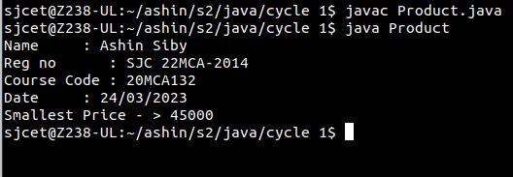

2) Read 2 matrices from the console and perform matrix addition.

Code:

public class AddMatrices {

public static void main(String[] args) {

System.out.println("Name : APARNA MOHAN");

System.out.println("Reg no : SJC 22MCA-2013");

System.out.println("Course code : 20MCA132");

System.out.println("Date : 24/3/2023");

int rows = 2, columns = 3;

int[][] firstMatrix = { {2, 3, 4}, {5, 2, 3} };

int[][] secondMatrix = { {-4, 5, 3}, {5, 6, 3} };

// Adding Two matrices

int[][] sum = new int[rows][columns];

for(int i = 0; i < rows; i++) {

for (int j = 0; j < columns; j++) {

sum[i][j] = firstMatrix[i][j] + secondMatrix[i][j];

}

}

// Displaying the result

System.out.println("Sum of two matrices is: ");

for(int[] row : sum) {

for (int column : row) {

System.out.print(column + " ");

}

System.out.println();

}

}

}

Output

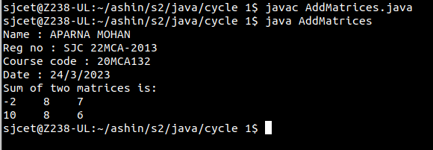

3) Add complex numbers

Code:

import java.util.Scanner;

public class ComplexAddition {

public static void main(String[] args) {

Scanner input = new Scanner(System.in);

System.out.print("Enter the real part of the first complex number: ");

double real1 = input.nextDouble();

System.out.print("Enter the imaginary part of the first complex

number: ");

double imaginary1 = input.nextDouble();

System.out.print("Enter the real part of the second complex number:

");

double real2 = input.nextDouble();

System.out.print("Enter the imaginary part of the second complex

number: ");

double imaginary2 = input.nextDouble();

double realResult = real1 + real2;

double imaginaryResult = imaginary1 + imaginary2;

System.out.println("Name : APARNA MOHAN");

System.out.println("Reg no : SJC 22MCA-2013");

System.out.println("Course code : 20MCA132");

System.out.println("Date : 24/3/2023");

System.out.println("The sum of the two complex numbers is: " +

realResult + " + " + imaginaryResult + "i");

}

}

Output

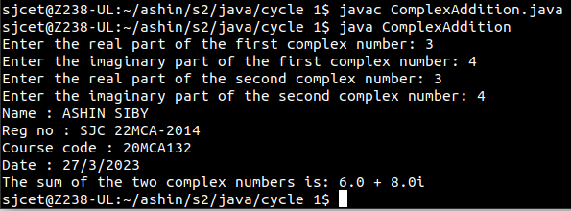

4) Read a matrix from the console and check whether it is symmetric or not.

Code:

import java.util.Scanner;

public class SymmetricMatrix

{

public static void main(String[] args)

{

System.out.println("Name : APARNA MOHAN");

System.out.println("Reg no : SJC 22MCA-2013");

System.out.println("Course code : 20MCA132");

System.out.println("Date : 24/3/2023");

Scanner mat = new Scanner(System.in);

System.out.println("Enter the no. of rows : ");

int rows = mat.nextInt();

System.out.println("Enter the no. of columns : ");

int cols = mat.nextInt();

int matrix[][] = new int[rows][cols];

System.out.println("Enter the elements :");

for (int i = 0; i < rows; i++)

{

for (int j = 0; j < cols; j++)

{

matrix[i][j] = mat.nextInt();

}

}

System.out.println("The matrix is :");

for (int i = 0; i < rows; i++)

{for (int j = 0; j < cols; j++)

{

System.out.print(matrix[i][j]+"\t");

}

System.out.println();

}

if(rows != cols)

{

System.out.println("The given matrix is not a square matrix");

}

else

{

boolean symmetric = true;

for (int i = 0; i < rows; i++)

{

for (int j = 0; j < cols; j++)

{

if(matrix[i][j] != matrix[j][i])

{

symmetric = false;

break;

}

}

}

if(symmetric)

{

System.out.println("The given matrix is symmetric.");

}

else

{

System.out.println("The given matrix is not symmetric.");

}

}

mat.close();}

}

Output

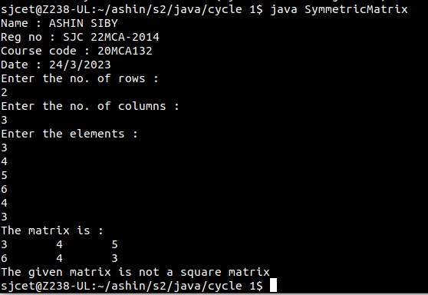

5) Create CPU with attribute price. Create inner class Processor (no. of cores, manufacturer) and static nested class RAM (memory, manufacturer). Create an object of CPU and print information of Processor and RAM.

Code:

public class cpu{

class processor{

int cores;

String producer;

processor(int noC, String manu){

cores=noC;

producer=manu;

}

void display(){

System.out.println("\nPROCESSOR DETAILS");

System.out.println("No. of Cores = "+cores);

System.out.println("Manufacturer = "+producer+"\n");

}

}

static class ram{

int mem;

String manuf;

ram(int memory,String producer ){

mem=memory;

manuf=producer;

}

void display(){

System.out.println("Name : APARNA MOHAN");

System.out.println("Reg no : SJC 22MCA-2013");

System.out.println("Course code : 20MCA132");

System.out.println("Date : 24/3/2023");

System.out.println("\nRAM DETAILS");

System.out.println("Memory = "+mem+" GB");

System.out.println("Manufacturer = "+manuf+"\n");

}

}

public static void main(String[] args) {cpu.ram obj1= new cpu.ram(8,"Intel");

cpu obj2 = new cpu();

cpu.processor obj3 = obj2.new processor(8,"Samsung");

obj1.display();

obj3.display();

}}

Output

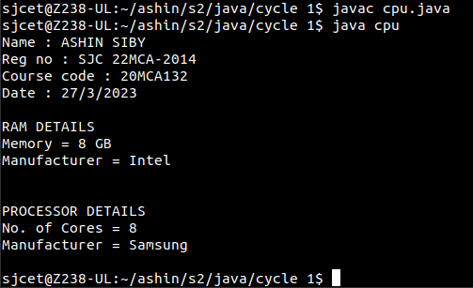

Cycle - 2

1) Program to Sort strings.

Code:

import java.util.Scanner;

import java.util.Arrays;

public class sort {

public static void main(String[] args) {

int i,j;

Scanner sc = new Scanner(System.in);

System.out.println("SANUP");

System.out.println("SJC22MCA-2048");

System.out.println("12-4-2023");

System.out.println("");

System.out.println("Enter the number of words");

int num=sc.nextInt();

String word[]=new String[num];

sc.nextLine();

for( i=0;i<num;i++){

System.out.println("\nEnter a Word\n");

word[i]=sc.nextLine();

}

for( i=0;i<num-1;i++){

for( j=i+1;j<num;j++){

if(word[i].compareTo(word[j])>0){

String temp = word[i];

word[i]=word[j];

word[j]=temp;

}

}

}

System.out.println("Sorted String using compareTo function="+Arrays.toString(word));

System.out.println(word);

}

}

Output

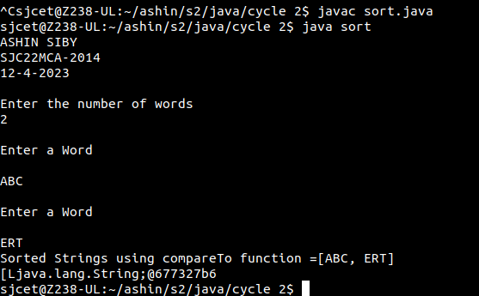

2) Search for an element in an array.

Code:

import java.util.Scanner;

public class search {

public static void main(String[] args) {

int i,j,x=0;

boolean state = false;

Scanner sc = new Scanner(System.in);

System.out.println("SANUP");

System.out.println("SJC22MCA-2048");

System.out.println("12-4-2023");

System.out.println("");

System.out.println("Enter the number of elemets in array");

int num=sc.nextInt();

String word[]=new String[num];

sc.nextLine();

for( i=0;i<num;i++){

System.out.println("\nEnter a Word\n");

word[i]=sc.nextLine();

}

System.out.println("Enter the element to Search");

String search = sc.nextLine();

for( i=0;i<num;i++){

if(word[i].equals(search)){

x = i;

state = true;

}

}

if(state){

System.out.println("Element found at position = "+x);

}

functionelse{

System.out.println("Element found not found");

}

}

}

Output

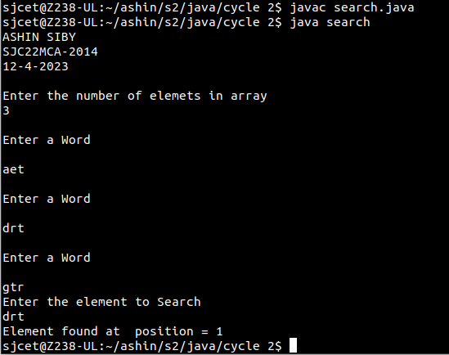

3) Perform string manipulations

Code:

import java.util.Scanner;

public class string {

public static void main(String[] args) {

System.out.println("Enter The String");

Scanner sc = new Scanner(System.in);

String str1 = sc.nextLine();

System.out.println("SANUP");

System.out.println("SJC22MCA-2048");

System.out.println("12-4-2023");

System.out.println("");

System.out.println("Length of String = "+str1.length());

System.out.println("Character at First position = "+str1.charAt(1));

System.out.println("String Contains 'Col' sequence :"+str1.contains("Col"));

System.out.println("String ends with e : "+str1.endsWith("e"));

System.out.println("Replace'col' with 'kol': "+str1.replaceAll("Col","kol"));

System.out.println("LOWERCASE : "+str1.toLowerCase());

System.out.println("UPPERCASE : "+str1.toUpperCase());

}

}

Output

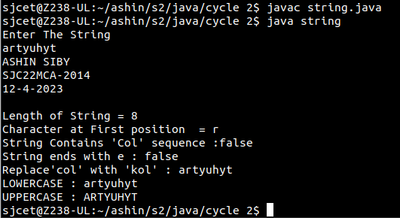

4) Program to create a class for Employee having attributes eNo, eName, eSalary. Read n employ information and Search for an employee given eNo, using the concept of Array of Objects.

Code:

import java.util.Scanner;public class employee {

int eNo;

String eName;

double eSalary;

public void getdetails(){

Scanner sc = new Scanner(System.in);

System.out.println("\nEnter the Employee details");

System.out.println("Employee number : ");

eNo=sc.nextInt();

System.out.println("Name : ");

sc.nextLine();

eName=sc.nextLine();

System.out.println("Salary : ");

eSalary=sc.nextDouble();

}

void display(){

System.out.println("Empolyee No :"+eNo);

System.out.println("Name :"+eName);

System.out.println("Salary Amount"+eSalary+"\n");

}

public static void main(String[] args) {

System.out.println("SANUP");

System.out.println("SJC22MCA-2048");

System.out.println("12-4-2023");

System.out.println("");

System.out.println("\nEnter the No. of Employee's");

Scanner sc1 = new Scanner(System.in);

int num = sc1.nextInt();

employee arr[]=new employee[num];

for(int i =0;i<num;i++){

arr[i]=new employee();

arr[i].getdetails();

}

System.out.println("\nInformations of all the employee's");

for(int i=0;i<num;i++){

arr[i].display();

}

boolean state = false;System.out.println("\nEnter the Employee Number to get details of a

employee");

int num2= sc1.nextInt();

for(int i=0;i<num;i++){

if(arr[i].eNo==num2){

System.out.println("\nEmployee details");

arr[i].display();

}

}

}

}

Output

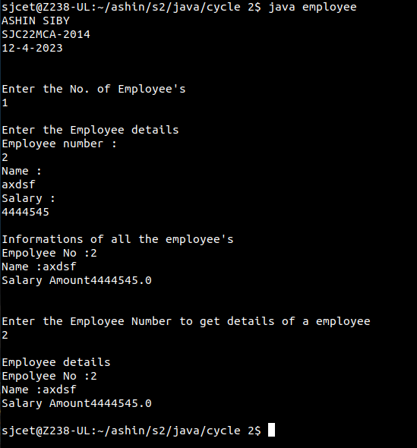

CYCLE – 3

1) Area of different shapes using overloaded functions.

Code:

import java.util.Scanner;

public class area{

public static void main(String[] args){

int s,sa,l,b,ra;

Scanner sc= new Scanner(System.in);

System.out.println("Enter side of square : ");

s=sc.nextInt();

sa=Square(s);

System.out.println("Enter length, breadth of reactangle : ");

l=sc.nextInt();

b=sc.nextInt();

ra=Square(l,b);

System.out.println("Enter length,breadth,height of cuboid : ");

int cl,cb,ch,ca;

cl=sc.nextInt();

cb=sc.nextInt();

ch=sc.nextInt();

ca=Square(cl,cb,ch);

System.out.println("Ashin Siby");

System.out.println("SJC22MCA-2014");

System.out.println("07-06-2023");

System.out.println("");

System.out.println("Area of square-> "+sa);

System.out.println("Area of rectangle-> "+ra);

System.out.println("Area of cuboid-> "+ca);

}

public static int Square(int x){

int a;

a=x*x;

return a;

}

public static int Square(int x, int y)

{

int a;

a=x*y;

return a;

}

public static int Square(int x,int y,int z)

{

int a;

a=2*(x*y)+2*(x*z)+2*(y*z);

return a;

}

}

Output

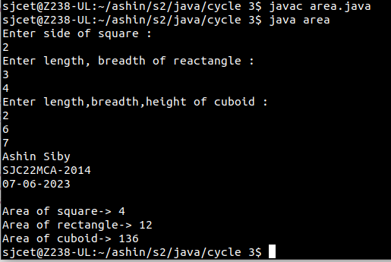

2) Create a class ‘Employee’ with data members Empid, Name, Salary, Address and constructors to initialize the data members. Create another class ‘Teacher’ that inherit the properties of class employee and contain its own data members department, Subjects taught and constructors to initialize these data members and also include display function to display all the data members. Use array of objects to display details of N teachers.

Code:

import java.util.Scanner;

class Employee {

protected int empId;

protected String name;

protected double salary;

protected String address;

public Employee(int empId, String name, double salary, String address) {

this.empId = empId;

this.name = name;

this.salary = salary;

this.address = address;

}

}

class Teacher extends Employee {

private String department;

private String subjectsTaught;

public Teacher(int empId, String name, double salary, String address, String department, String subjectsTaught) {

super(empId, name, salary, address);

this.department = department;

this.subjectsTaught = subjectsTaught;

}

public void display() {

System.out.println("Employee ID: " + empId);

System.out.println("Name: " + name);

System.out.println("Salary: " + salary);

System.out.println("Address: " + address);

System.out.println("Department: " + department);

System.out.println("Subjects Taught: " + subjectsTaught);

System.out.println("---------------------------");

}

}

public class Main {

public static void main(String[] args) {

Scanner scanner = new Scanner(System.in);

System.out.println("---------------------------");

System.out.println("Ashin Siby");

System.out.println("22MCA014");

System.out.println("09-06-2023");

System.out.println("---------------------------");

System.out.print("Enter the number of teachers: ");

int numTeachers = scanner.nextInt();

scanner.nextLine(); // Consume the newline character

Teacher[] teachers = new Teacher[numTeachers];

for (int i = 0; i < numTeachers; i++) {

System.out.println("Enter details for Teacher " + (i + 1));

System.out.print("Employee ID: ");

int empId = scanner.nextInt();

scanner.nextLine();

System.out.print("Name: ");

String name = scanner.nextLine();

System.out.print("Salary: ");

double salary = scanner.nextDouble();

scanner.nextLine();

System.out.print("Address: ");

String address = scanner.nextLine();

System.out.print("Department: ");

String department = scanner.nextLine();

System.out.print("Subjects Taught: ");

String subjectsTaught = scanner.nextLine();

teachers[i] = new Teacher(empId, name, salary, address, department, subjectsTaught);

}

scanner.close();

System.out.println("\nDetails of Teachers:");

for (Teacher teacher : teachers) {

teacher.display();

}

}

}

Output

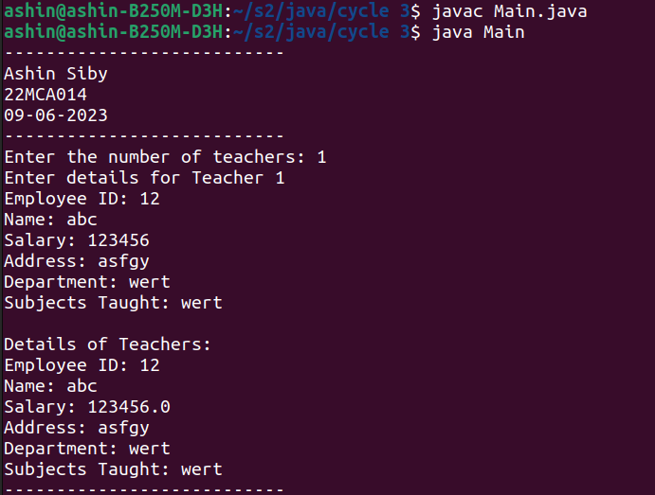

3) Create a class ‘Person’ with data members Name, Gender, Address, Age and a constructor to initialize the data members and another class ‘Employee’ that inherits the properties of class Person and also contains its own data members like Empid, Company_name, Qualification, Salary and its own constructor. Create another class ‘Teacher’ that inherits the properties of class Employee and contains its own data members like Subject, Department, Teacherid and also contain constructors and methods to display the data members. Use array of objects to display details of N teachers.

Code:

import java.util.*;

class Person{

String Name;

String Gender;

String Address;

String Age;

public Person(String Name,String Gender,String Address,String Age){

this.Name=Name;

this.Gender=Gender;

this.Address=Address;

this.Age=Age;

}

}

class Employee extends Person {

String Empid;

String Company_Name;

String Qualification;

String Salary;

public Employee(String Name,String Gender,String Address,String Age ,String Empid,String Company_Name, String Qualification,String Salary){

super(Name,Gender,Address,Age);

this.Empid= Empid;

this.Company_Name=Company_Name;

this.Qualification=Qualification;

this.Salary=Salary;

}

}

class Teacher extends Employee{

String Teacherid;

String Department;

String Subject;

public Teacher(String Name,String Gender,String Address,String Age,String Empid,String Company_Name,String Qualification,String Salary,String Teacherid,String Department,String Subject){

super(Name,Gender,Address,Age,Empid,Name,Qualification, Salary);

this.Teacherid=Teacherid;

this.Department=Department;

this.Subject=Subject;

}

public void read(){

Scanner in =new Scanner(System.in);

System.out.println("enter the Name=");

Name=in.nextLine();

System.out.println("enter the Gender=");

Gender=in.nextLine();

System.out.println("enter the Address=");

Address=in.nextLine();

System.out.println("enter the Age=");

Age=in.nextLine();

System.out.println("enter the Employ id=");

Empid=in.nextLine();

System.out.println("enter the Company Name=");

Company_Name=in.nextLine();

System.out.println("enter the Qualification=");

Qualification=in.nextLine();

System.out.println("enter the Salary=");

Salary=in.nextLine();

System.out.println("enter the Teacher id=");

Teacherid=in.nextLine();

System.out.println("enter the Department=");

Department=in.nextLine();

System.out.println("Enter the Subject=");

Subject=in.nextLine();

}

public void display(){

System.out.println("_______Employee Details_________");

System.out.println("Name="+ Name);

System.out.println("Gender=" + Gender);

System.out.println("Address=" + Address);

System.out.println("Age=" + Age);

System.out.println("Empid=" + Empid);

System.out.println("Company Name=" + Company_Name);

System.out.println("Qualification=" + Qualification);

System.out.println("Salary=" + Salary);

System.out.println("Teacher id=" + Teacherid);

System.out.println("Department=" + Department);

System.out.println("Subject=" + Subject);

System.out.println("+++++++++++++++++++++++++++++++++++++++++++");

}

}

public class InheritancePerson{

public static void main(String Args[]){

System.out.println("Ashin Siby");

System.out.println("SJC22MCA-2014");

System.out.println("07-06-2023");

System.out.println("20MCA132 , Object Oriented Programming Lab \n\n");

int i,n;

Scanner in =new Scanner(System.in);

System.out.println("Enter the Number of employee=");

n=in.nextInt();

Teacher T[] = new Teacher[n];

for(i=0;i<n;i++){

T[i]=new

Teacher("Name","Gender","Address","Age","Empid","Name","Qualification","Salary","Teacherid","Department","Subject");

T[i].read();

}

for(i=0;i<n;i++){

T[i].display();

}

}

}

Output

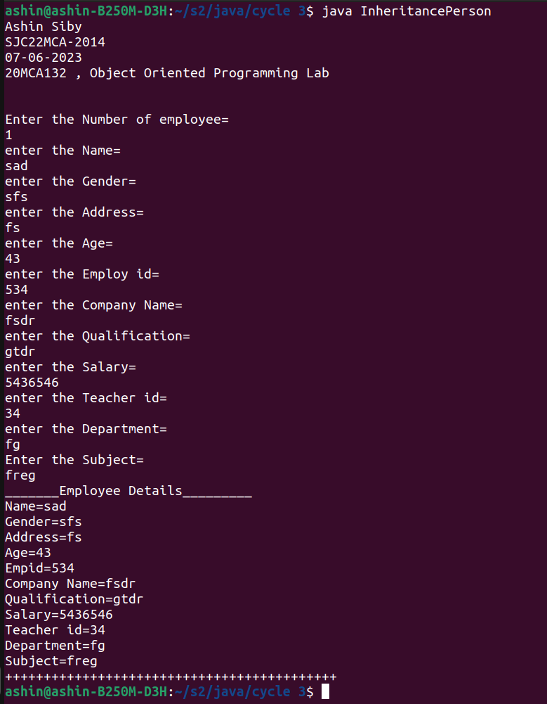

4) Write a program has class Publisher, Book, Literature and Fiction. Read the information and print the details of books from either the category, using inheritance.

Code:

import java.util.Scanner;

class Publisher{

int publisher_id;

String publisher_name;

Publisher(int publisher_id, String publisher_name){

this.publisher_id= publisher_id;

this.publisher_name= publisher_name;

}

}

class Book extends Publisher{

int book_id;

String book_name;

Book(int publisher_id, String publisher_name, int book_id, String book_name) {

super(publisher_id, publisher_name);

this.book_id= book_id;

this.book_name= book_name;

}

}

class Literature extends Book{

int literature_id;

String literature_theme;

Literature(int publisher_id, String publisher_name, int book_id, String book_name, int literature_id, String literature_theme) {

super(publisher_id, publisher_name, book_id, book_name);

this.literature_id= literature_id;

this.literature_theme= literature_theme;

}

void displayDetails() {

System.out.println("The publisher ID of the book is: " + this.publisher_id);

System.out.println("The publisher name of the book is: " + this.publisher_name);

System.out.println("The Book ID of the book is: " + this.book_id);

System.out.println("The Book name of the book is: " + this.book_name);

System.out.println("The Literature ID of the book is: " + this.literature_id);

System.out.println("The Literature theme of the book is: " + this.literature_theme);

}

}

class Fiction extends Book{

int fiction_id;

String fiction_theme;

Fiction(int publisher_id, String publisher_name, int book_id, String book_name, int fiction_id, String fiction_theme) {

super(publisher_id, publisher_name, book_id, book_name);

this.fiction_id= fiction_id;

this.fiction_theme= fiction_theme;

}

void displayDetails() {

System.out.println("The publisher ID of the book is: " + this.publisher_id);

System.out.println("The publisher name of the book is: " + this.publisher_name);

System.out.println("The Book ID of the book is: " + this.book_id);

System.out.println("The Book name of the book is: " + this.book_name);

System.out.println("The Fiction ID of the book is: " + this.fiction_id);

System.out.println("The Fiction theme of the book is: " + this.fiction_theme);

}

}

public class BookInheritance {

public static void main(String[] args) {

System.out.println("Ashin Siby");

System.out.println("SJC22MCA-2014");

System.out.println("10-06-2023");

System.out.println("20MCA132 , Object Oriented Programming Lab \n\n");

Literature literature= new Literature(10,"Robert Kiyozaki",200,"Rich Dad Poor Dad",2001,"Drama");

Fiction fiction= new Fiction(101, "F. Scott Fitzgerald", 301, "The Great Gatsby",301, "Fantasy-Fiction");

literature.displayDetails();

System.out.println("\n");

fiction.displayDetails();

}

}

Output

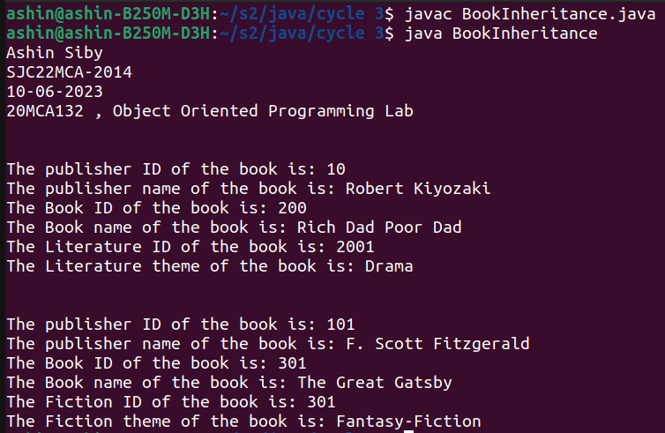

5) Create classes Student and Sports. Create another class Result inherited from Student and Sports. Display the academic and sports score of a student.

Code:

import java.util.Scanner;

class student{

int roll;

String name;

int phy,eng,maths;

student(){

Scanner sc1= new Scanner(System.in);

System.out.println("Enter the roll number:");

roll =sc1.nextInt();

System.out.println("Enter name:");

name=sc1.next();

System.out.println("Enter physics mark:");

phy =sc1.nextInt();

System.out.println("Enter english mark:");

eng =sc1.nextInt();

System.out.println("Enter maths mark:");

maths =sc1.nextInt();

}

}

class sports extends student{

int fscore,cscore;

sports(){

Scanner sc2= new Scanner(System.in);

System.out.println("Enter football score:");

fscore=sc2.nextInt();

System.out.println("Enter Cricket score:");

cscore=sc2.nextInt();

}

}

class Result extends sports{

void display(){

System.out.println("Academic Details"+"\n"+" ");

System.out.println("Name : " + name);

System.out.println("Roll No : " + roll);

System.out.println("");

System.out.println("MARKS" +"\n" + " ");

System.out.println("Physics :" + phy);

System.out.println("English :" + eng);

System.out.println("Maths :" + maths);

System.out.println("Total subject mark:"+(phy+eng+maths));

System.out.println("");

System.out.println("SPORTS SCORE" +"\n"+" ");

System.out.println("Football : " + fscore);

System.out.println("Cricket : " + cscore);

System.out.println("Total Sports mark:"+(fscore+cscore));

}

}

public class FResult{

public static void main(String[] args) {

System.out.println("Ashin Siby");

System.out.println("SJC22MCA-2014");

System.out.println("12-06-2023");

System.out.println("20MCA132 , Object Oriented Programming Lab \n\n");

Result rs =new Result();

rs.display();

}

}

Output

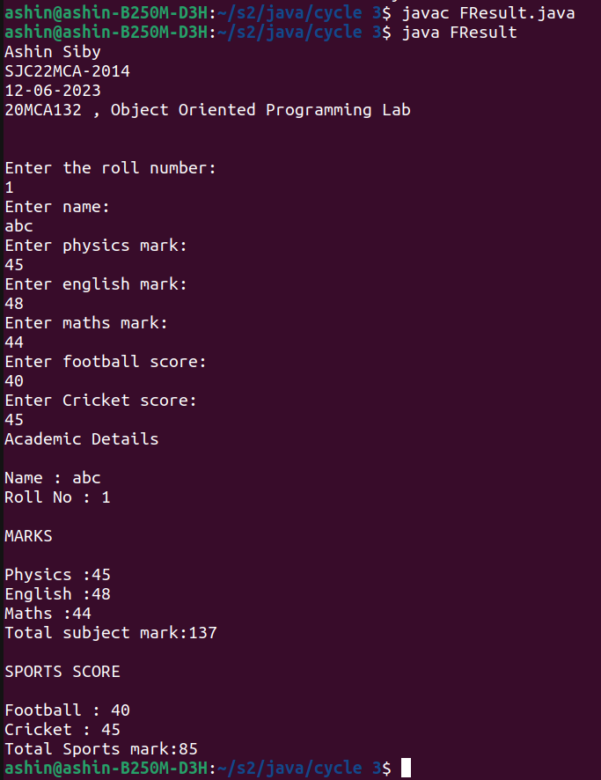

6) Create an interface having prototypes of functions area() and perimeter(). Create two

classes Circle and Rectangle which implements the above interface. Create a menu driven

program to find area and perimeter of objects.

Code:

import java.util.*;

import java.lang.*;

interface Shape {

float pi = 3.14F;

float area();

float perimeter();

}

class Circle implements Shape {

Scanner sc = new Scanner(System.in);

int r;

public float area() {

System.out.print("Enter the radius : ");

r = Integer.parseInt(sc.nextLine());

return (pi * r * r);

}

public float perimeter() {

System.out.print("Enter the radius : ");

r = Integer.parseInt(sc.nextLine());

return (2 * pi * r);

}

}

class Rectangle implements Shape {

Scanner sc = new Scanner(System.in);

int l, b;

public float area() {

System.out.print("Enter the Length : ");

l = Integer.parseInt(sc.nextLine());

System.out.print("Enter the breadth : ");

b = Integer.parseInt(sc.nextLine());

return (l * b);

}

public float perimeter() {

System.out.print("Enter the Length : ");

l = Integer.parseInt(sc.nextLine());

System.out.print("Enter the breadth : ");

b = Integer.parseInt(sc.nextLine());

return (2 * (l + b));

}

}

class ShapeInterface {

public static void main(String args[]) {

System.out.println("Ashin Siby");

System.out.println("SJC22MCA-2014");

System.out.println("13-06-2023");

System.out.println("20MCA132 , Object Oriented Programming Lab \n\n");

Scanner sc = new Scanner(System.in);

Circle c = new Circle();

Rectangle r = new Rectangle();

int ch;

while (true) {

System.out.println("1:Area of Circle");

System.out.println("2:Perimeter of Circle");

System.out.println("3:Area of Rectangle");

System.out.println("4:Perimter of Rectangle");

System.out.println("5:EXIT");

System.out.print("Enter choice : ");

ch = Integer.parseInt(sc.nextLine());

switch (ch) {

case 1:

float ar = c.area();

System.out.println("Area :" + ar);

System.out.println("**-----------** --------- **");

break;

case 2:

float pr = c.perimeter();

System.out.println("Perimeter of Circle = "+pr);

System.out.println("**-----------** --------- **");

break;

case 3:

float a = r.area();

System.out.println("Area :" + a);

System.out.println("**-----------** --------- **");

break;

case 4:

float pr1 = r.perimeter();

System.out.println("Perimeter of Rectangle = "+pr1);

System.out.println("**-----------** --------- **");

break;

case 5:

System.out.println("Exiting the Program!!!!!");

System.exit(0);

default:

System.out.println("invalid!");

}

}

}

}

Output

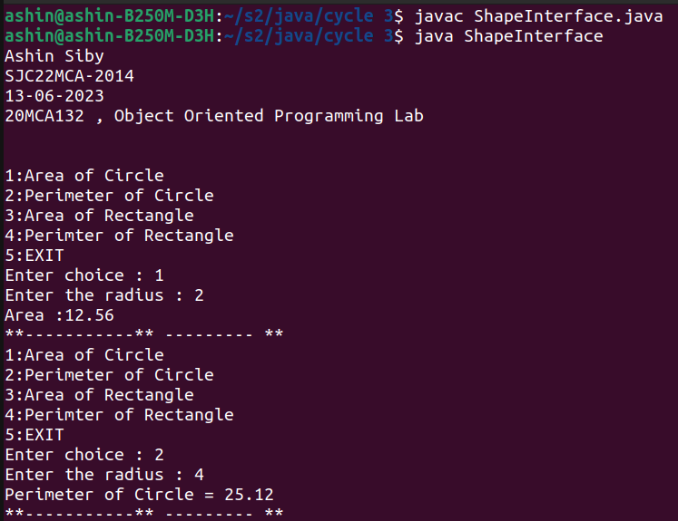

7)Prepare bill with the given format using calculate method from interface.

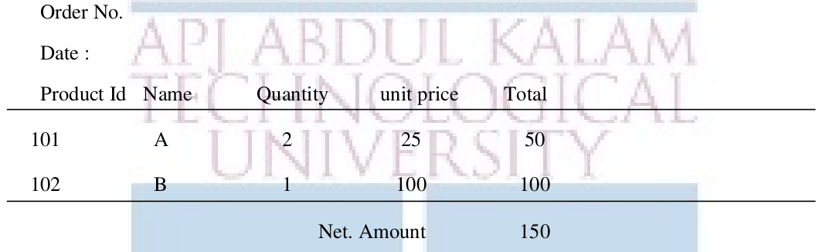

Code:

import java.text.SimpleDateFormat;

import java.util.Date;

interface bill{

void cal();

}

class details1 implements bill{

int pid=101,q=2,uprice=25,t1;

String name1="A";

public void cal(){

t1=q*uprice;

}

}

class details2 extends details1 {

int pid2=102,q2=1,uprice2=100,t2;

String name2="B";

SimpleDateFormat f=new SimpleDateFormat("dd/MM/yy");

Date d= new Date();

public void cal(){

super.cal();

t2=q2*uprice2;

}

public void display(){

System.out.println("Order No.384\n");

System.out.println("Date: "+f.format(d));

System.out.println("\nProduct Id\tName\t\tQuantity\tunit price\tTotal");

System.out.println("___________________________________________________________________________");

System.out.println(pid+"\t\t"+name1+"\t\t"+q+"\t\t"+uprice+"\t\t"+t1);

System.out.println(pid2+"\t\t"+name2+"\t\t"+q2+"\t\t"+uprice2+"\t\t"+t2);

System.out.println("____________________________________________________________________________");

System.out.println("\t\t\t\t\t\tNet.Amount"+"\t"+(t1+t2));

}

}

public class Electricitybill{

public static void main(String[] args) {

System.out.println("Ashin Siby");

System.out.println("SJC22MCA-2014");

System.out.println("15-06-2023");

System.out.println("20MCA132 , Object Oriented Programming Lab \n\n");

details2 obj2=new details2();

obj2.cal();

obj2.display();

}

}

Output

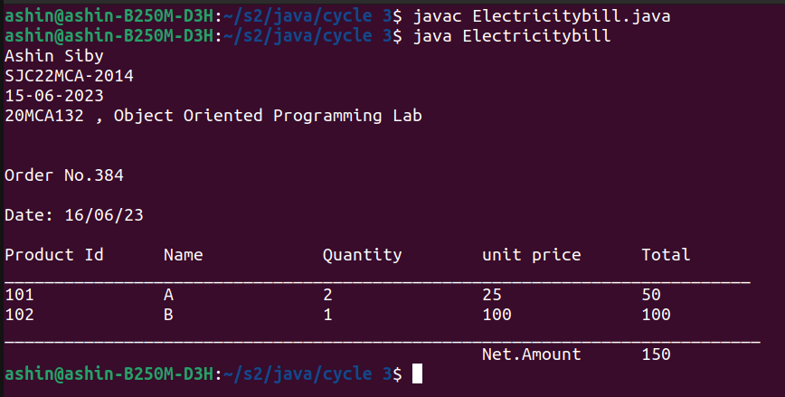

CYCLE – 4

1) Create a Graphics package that has classes and interfaces for figures Rectangle, Triangle, Square and Circle. Test the package by finding the area of these figures.

2) Create an Arithmetic package that has classes and interfaces for the 4 basic arithmetic operations. Test the package by implementing all operations on two given numbers